Agar aapka folder structure aisa hai:

MyProject

├── UploadFiles

│ └── Images

Aur aap image UploadFiles/Images me save karna chahte hain (i.e. **project root** me, **wwwroot ke bahar**), to Path.Combine aap is tarah likhenge:

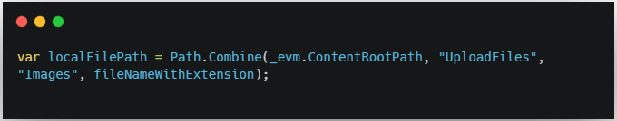

**🔍 Explanation:**

* _evm.ContentRootPath → aapke project ka **root path** deta hai.
* "UploadFiles" → root ke andar folder.
* "Images" → uske andar subfolder.
* fileNameWithExtension → jaise "student1.jpg"

**🔧 Example:**

Agar ContentRootPath = "C:\MyApp"  
Aur fileNameWithExtension = "student1.jpg"

To:



**🛑 Important:**

Agar ye image aapko **browser se access** karni ho (public URL), to ye folder **wwwroot ke andar hona chahiye**.  
Warna aapko manual static file configuration karni padegi.

Aap chahein to aapki structure aise bhi ho sakti hai:

wwwroot

└── UploadFiles

└── Images



👉 Use WebRootPath jab wwwroot ke andar save karna ho.  
👉 Use ContentRootPath jab project root ke andar (but outside wwwroot) save karna ho.